

REBATE
MANAGEMENT SYSTEM
System Workflow

Table of Contents
User Login Process 3
Set a new password 4
Rebate Program Creation Process 6
Header Part 7
Search Rebate Program 7
Rebate Code 8
Rebate Type 8
Sales Employee 9
Date From and Date To 9
Frequency 9
Quota Type 10
With Quota 10
Without Quota 10
Details Part 11
Import 12
Export 12
Add Customer 13
Filter Customers 14
Add Item 15
Filter Items 16
Rebate Computation and Payout Generation 17
Customer Modal 17
Customer Details 18
Analytics 19
Transaction Log 20
Payout History 21

User Login Process

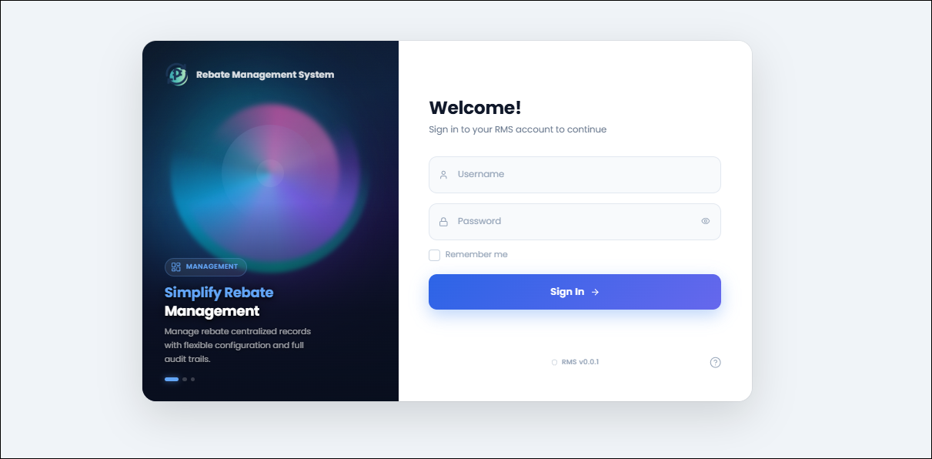

The Login Page serves as the entry point to the Rebate Management System (RMS). Users are required to authenticate their credentials before accessing the system's features and modules.

To proceed with login, the user must have an existing and active account in the User Management System (UMS). During authentication, the system validates the entered username and password against the user records maintained in UMS. Only authorized users with valid credentials are granted access to the RMS Homepage.

If the provided credentials are invalid or the user account does not exist in UMS, access to the system will be denied, and an appropriate error message will be displayed.

Set a new password

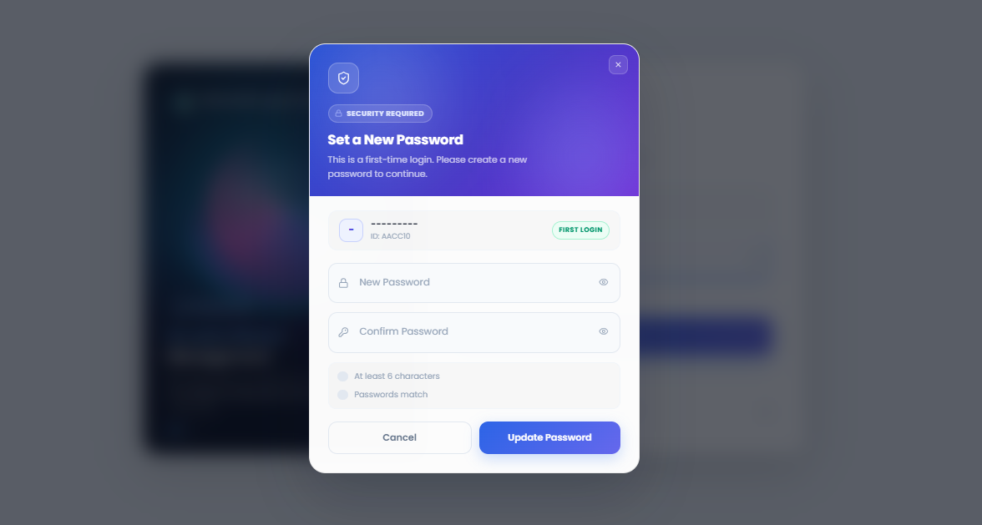

The Set New Password Page is displayed only to newly created users during their first login to the Rebate Management System (RMS). Newly provisioned accounts are initially assigned a temporary password (abc123) by the system administrator.

Upon successful authentication using the temporary password, the user is automatically redirected to the Set New Password modal, where they are required to create a new password before gaining access to the system. This security measure ensures that temporary credentials are replaced with a password known only to the user.

After successfully setting a new password, the system updates the user's account credentials and redirects the user back to the Login Page. The user must then log in again using their newly created password to access the RMS Homepage.

If a user forgets their password or requires a password reset in the future, they must contact the system administrator, who will reset the account and provide a new temporary password. The user will then be required to repeat the password change process upon their next login.

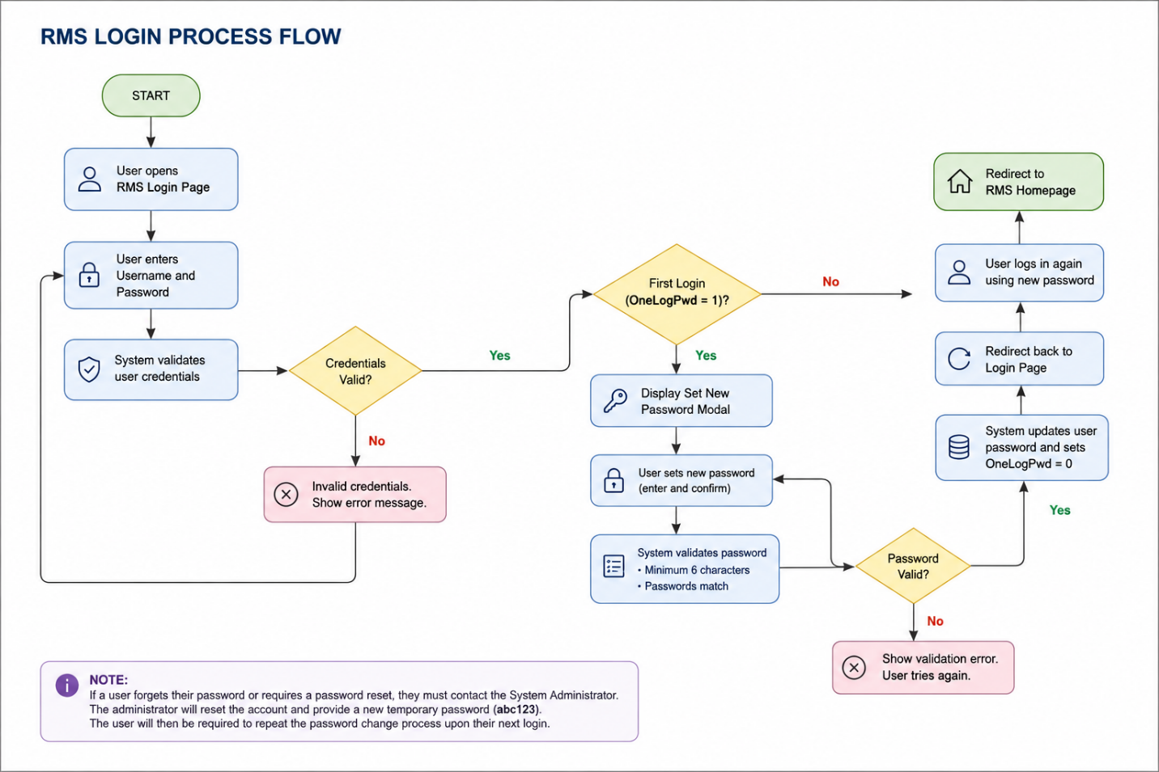

Rebate Program Creation Process

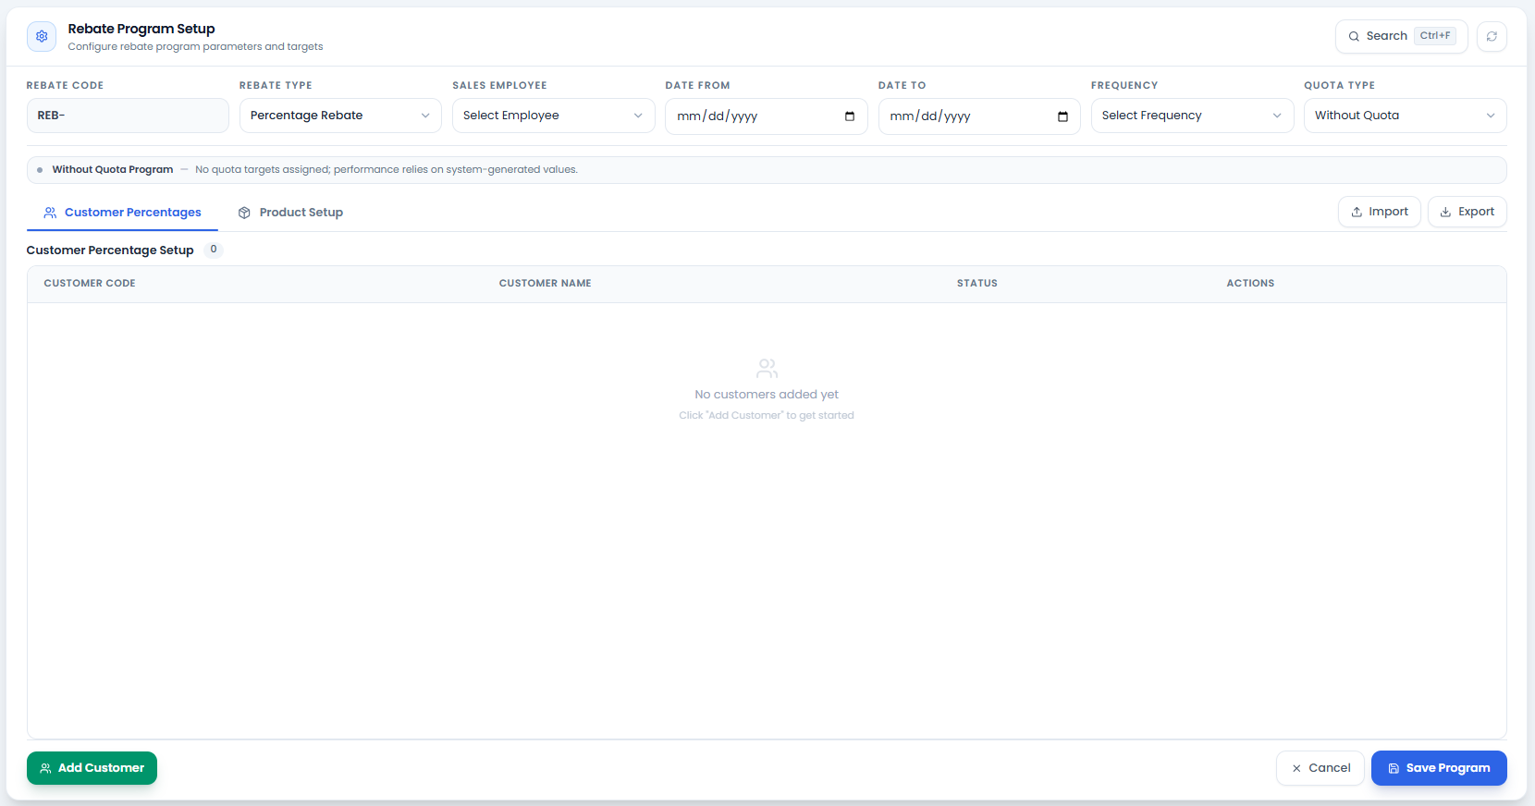

The Rebate Program Creation Process is used to configure and manage rebate programs within the Rebate Management System (RMS). During this process, users define the program details, select eligible customers and products, and establish the rebate computation rules and qualification requirements.

Users can assign specific customers and items to the rebate program, define rebate percentages or quota-based incentives, and specify the required purchase quantities that customers must achieve to earn rebates. These configurations ensure that rebate earnings are calculated accurately based on the program's defined criteria.

The setup process may vary depending on the database being used. While all supported databases follow the same core rebate management principles and overall workflow, certain fields, business rules, available options, customer classifications, product structures, and rebate configurations may differ from one database to another. Therefore, users should ensure that the rebate program is configured according to the specific requirements and data structure of the selected database.

The following describe the step-by-step procedure for creating and setting up a rebate program in the system.

Header

Search Rebate Program
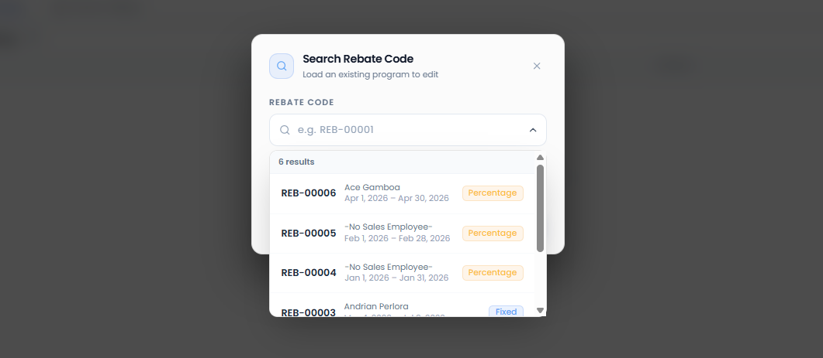

To find or edit an existing rebate program, users can click the Search button or use the keyboard shortcut Ctrl + F to quickly locate the desired record. The search functionality allows users to browse and retrieve rebate programs that have been previously created in the system.

Access to view, edit, or manage rebate programs is controlled through user permissions. As a result, users can only access rebate programs and functions that have been assigned to them by the system administrator. Unauthorized users will not be able to view or modify rebate programs beyond their permitted access rights.

Once a rebate program is selected from the search results, authorized users may review and update the program details as required.

Rebate Code
The Rebate Code is an automatically generated and incremented value assigned by the system whenever a new rebate program is created. The system retrieves the next available code from the database, ensuring that each rebate program has a unique identifier.

Users are not required to manually enter or modify the rebate code, as it is generated automatically during the creation process. This helps maintain consistency, prevents duplicate entries, and ensures proper record tracking within the system.

The Rebate Code can also be used as a search criterion when locating existing rebate programs. Users may click the Search button or press Ctrl + F and enter the rebate code to quickly find a specific rebate program.

Rebate Type
The Rebate Type determines how rebates will be calculated and applied within a rebate program. This field plays a significant role in the overall program setup, as it defines the rebate computation method that will be used for the selected customers and items.

The available rebate types may vary depending on the database being used. While some databases support Percentage, Fixed Amount, and Incremental rebate types, others may only support specific rebate types based on their configuration.

Users must select the appropriate rebate type when creating a rebate program. The selected rebate type will serve as the basis for defining the rebate rules, rebate values, and qualification criteria for the customers and products included in the program.

Sales Employee
The Sales Employee field identifies the sales representative responsible for managing and handling the assigned customers within a rebate program. In the program setup, customers included in the rebate configuration are typically linked to a specific sales employee who oversees their transactions and performance.

This role ensures proper assignment and tracking of customers under the correct sales representative, allowing better monitoring of sales activities and rebate eligibility. The sales employee effectively acts as the primary handler of all customers included in the rebate program setup.

Depending on the system configuration, a sales employee may be assigned to one or multiple customers within a program, ensuring organized distribution and accountability of customer management.

Date From and Date To
The Date From and Date To fields define the validity period of a rebate program. These parameters determine the exact time range during which the rebate rules are active and applicable for customer transactions.

This date range is also used as a filtering condition when retrieving transaction data from SAP or the database. Only sales transactions that fall within the specified period will be included in the rebate computation, along with the associated customers and items configured in the program.

For example, if a rebate program is set from January to March, only transactions posted within that period will be considered for rebate processing. Any transactions outside this date range will be excluded from the calculation.

Frequency
The Frequency field defines how often the rebate program is evaluated and how rebate earnings are calculated and released. It determines the interval at which customer performance is measured and serves as the basis for rebate payout computation.

Users can select a frequency such as Monthly or Quarterly, depending on the structure of the rebate agreement. This selection directly affects how customer sales and quota achievements are assessed within the defined program period.

For example:

If the frequency is set to Monthly, the customer must meet the required quota or conditions within each month to qualify for rebates.
If the frequency is set to Quarterly, the evaluation and qualification are based on the total performance within a three-month period.

The selected frequency also serves as the basis for rebate payout computation, ensuring that rebates are calculated consistently according to the defined schedule.

Quota Type
The Quota Setup defines whether a rebate program requires customers to meet a specific sales target (quota) or if rebates are calculated purely based on actual sales performance.

There are two types of quota configurations:

With Quota
In a With Quota setup, customers are required to achieve a defined quota within a specified period (monthly or quarterly, depending on the program frequency). The rebate eligibility and computation depend on whether the customer successfully meets or exceeds the assigned quota within that period. This setup enforces performance targets for customers as part of the rebate program.

Without Quota
In a Without Quota setup, no fixed target is required. Instead, the rebate is calculated based on the total sales quantity or amount recorded from SAP transactions within the defined date range. This is commonly used in percentage-based rebate programs, where the rebate is applied directly to overall sales performance without requiring customers to meet a minimum threshold.

Details Part

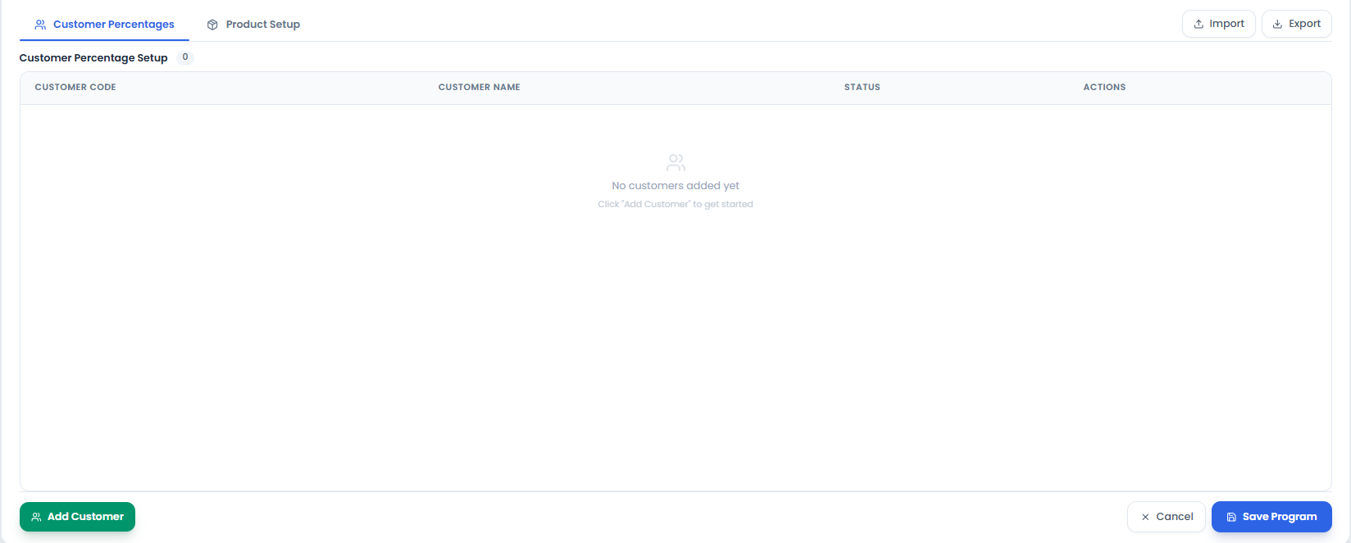

The Details Section provides a consolidated view of all customers and items that have been added to the rebate program. This section allows users to review the configured rebate setup and verify that the correct customers, products, quotas, and qualification requirements have been assigned.

Depending on the rebate program configuration, the Details Section displays the corresponding quota, required quantity, rebate value, and other relevant information for each customer-item combination. The displayed values are evaluated within the specified rebate period and frequency defined in the program setup.

For With Quota programs, this section shows the assigned quota that customers must achieve during the applicable monthly or quarterly period. For Without Quota programs, it displays the quantity or sales-based criteria used for rebate computation.

The Details Section serves as a reference for reviewing and validating the rebate program before it is saved and activated.

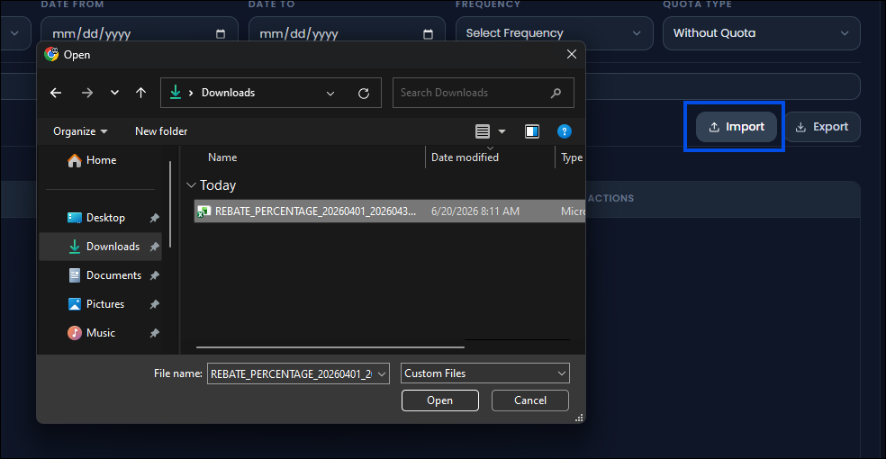
Import
The Import function allows users to reuse an existing rebate program setup instead of creating a new one from scratch. This feature is particularly useful when the new rebate program has a similar configuration to a previously created setup.

Users can first locate an existing rebate program by clicking the Find button or pressing Ctrl + F. Once the desired rebate program is found, it can be exported and saved as an Excel file. The saved file can then be imported into a new rebate program setup.

After importing, users may modify the configuration as needed, such as adding new customers, removing customers that are no longer included, updating items, adjusting quotas, or changing other program details. If the rebate program structure remains the same and only the rebate period changes, users can simply import the previous setup and update the applicable dates, significantly reducing setup time.

Export
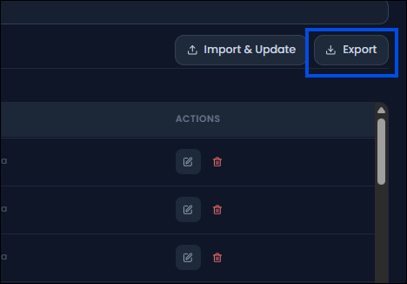
The Export function allows users to save the current rebate program setup into an Excel file for backup, reference, or future reuse.

When exported, the rebate program configuration—including customers, items, quotas, quantities, and other setup details—is automatically generated into an Excel file. This file can be stored locally and later imported when creating a similar rebate program.

The Export feature provides an efficient way to maintain copies of rebate program configurations and simplifies the process of creating future rebate programs by allowing users to edit an existing exported file instead of rebuilding the setup from the beginning.

Add Customer
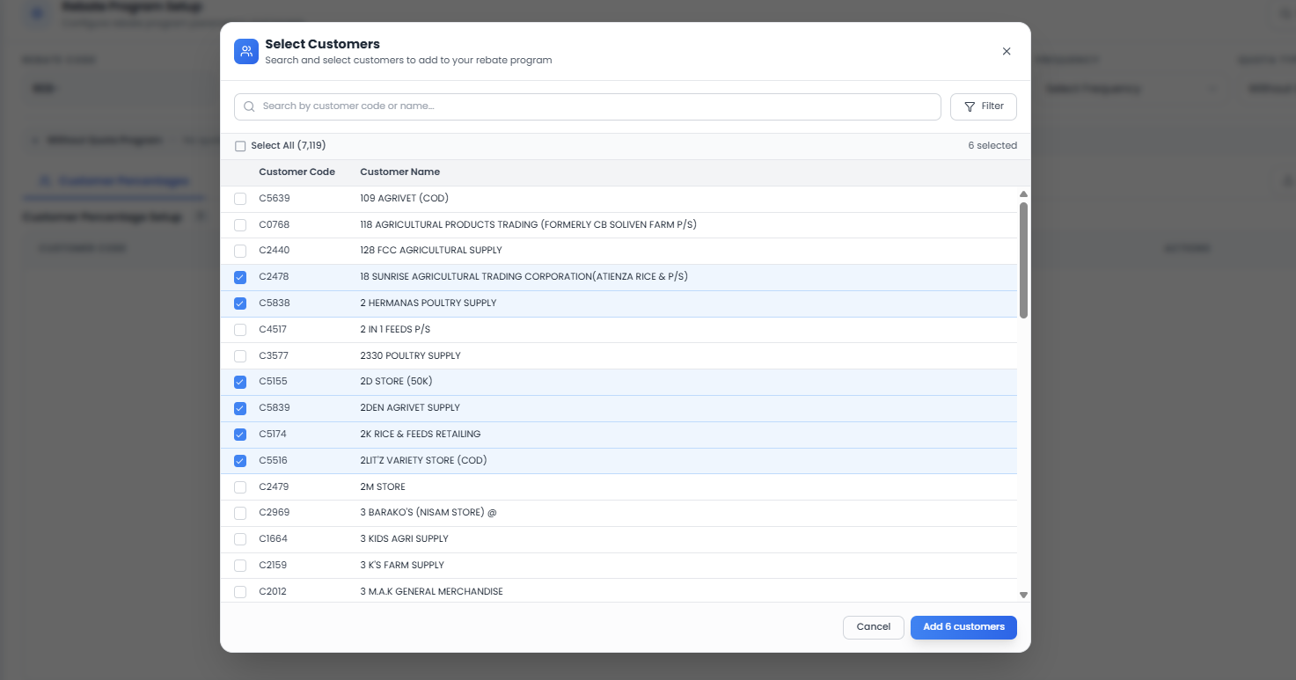

The Customer Selection section allows users to choose and assign the customers who will participate in the rebate program. The list of available customers may vary depending on the selected database, rebate type, sales employee assignment, and other program configurations.

Users should select the customers that are eligible for the specific rebate setup being created. Only the selected customers will be included in the rebate computation and evaluation process throughout the program period.

Once added to the rebate program, the selected customers become subject to the rebate rules, quotas, quantities, and qualification requirements defined in the program setup. Any transactions retrieved from SAP for rebate calculation will be validated against the customers included in this list.

Filter Customers
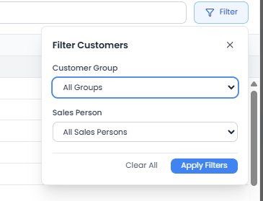
The Filter Customer function allows users to narrow down and display only the customers relevant to the rebate program setup. This feature helps users efficiently locate and select customers, especially when working with a large customer master list.

Customers can be filtered based on their Business Partner (BP) Group and Sales Employee assignment. By applying these filters, users can quickly view the customers that belong to a specific customer group or are handled by a particular sales representative.

This functionality simplifies the customer selection process and ensures that the appropriate customers are included in the rebate program according to the selected criteria.

Once the desired customers have been selected and the applied filters have been verified, users can click the Add Customer button to include the selected customers in the rebate program.

Upon clicking the button, the selected customers are transferred to the program's Details Section, where they become part of the rebate setup and are subject to the rebate rules, quotas, quantities, and qualification requirements defined in the program.

Add Item
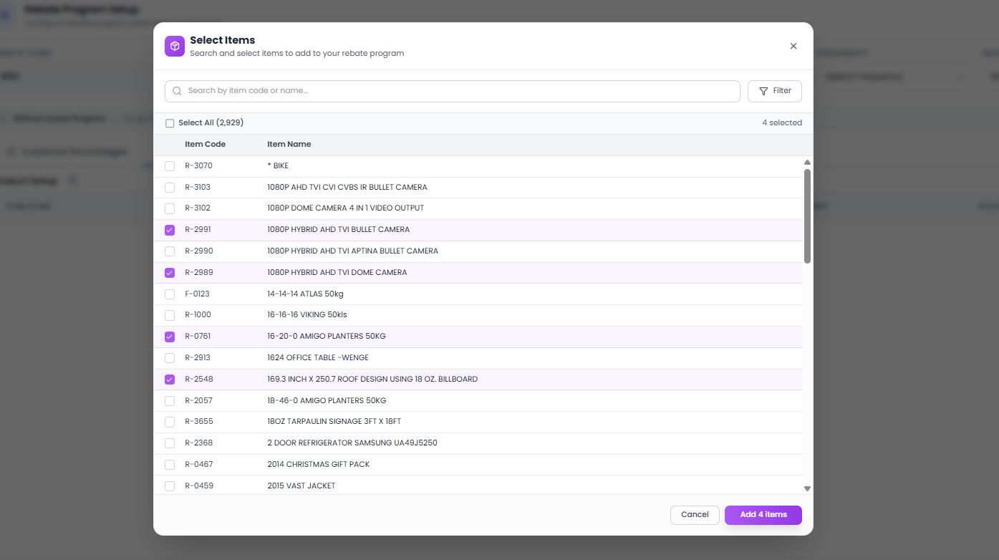

The Item Selection section allows users to choose the products that will be included in the rebate program. These items serve as the basis for determining which customer transactions are eligible for rebate computation.

Users can browse or filter the available items and select the products that are covered by the rebate program. Only the items added to the setup will be considered when the system retrieves and evaluates transaction data from SAP within the specified rebate period.

Once selected, the items become part of the rebate program and are subject to the rebate rules, quotas, quantities, and qualification criteria defined in the setup.

Filter Items
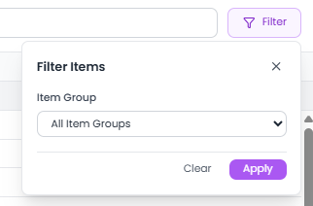
The Filter Items function allows users to narrow down the list of available items before adding them to the rebate program. This feature helps users quickly locate and select the products that are eligible for the rebate setup.

Items can be filtered based on their Item Group, allowing users to display only the products that belong to a specific category. This simplifies the item selection process, especially when dealing with a large number of products.
By applying the appropriate Item Group filter, users can efficiently identify and select the items that will be included in the rebate program.

Rebate Computation and Payout Generation

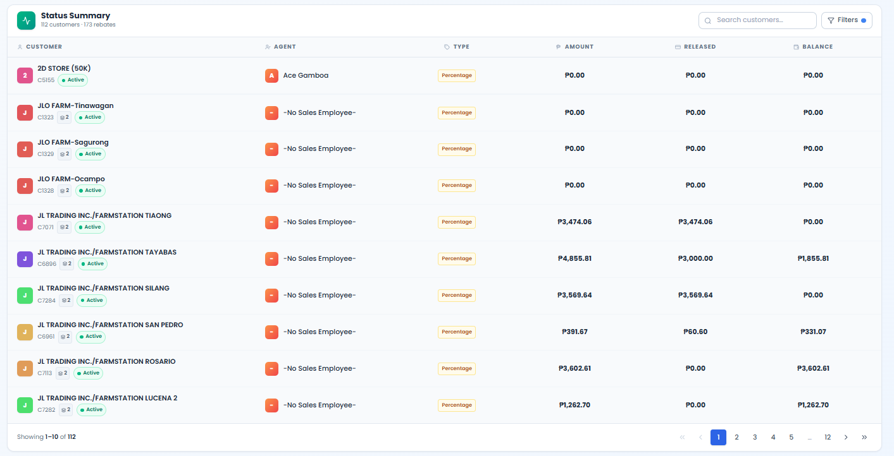

The Rebate Computation and Payout Generation module is responsible for calculating the rebates earned by customers and managing the release of rebate payouts based on the configured rebate program rules.
This module retrieves and evaluates customer transactions based on the rebate setup, including the selected customers, items, rebate type, quota requirements, frequency, and program period. The system then computes the eligible rebate amount for each customer according to the defined program criteria.
A Status Summary section is provided to give users an overview of all customers included in the rebate program. This section displays the rebate status and computation results for each customer, allowing users to monitor rebate earnings and payout activities.

Customer Modal
The Status Summary is designed to display a consolidated list of customers included in rebate programs. Instead of showing multiple entries for the same customer across different rebate programs, the system displays each customer only once, preventing duplicate records and making the summary easier to review.

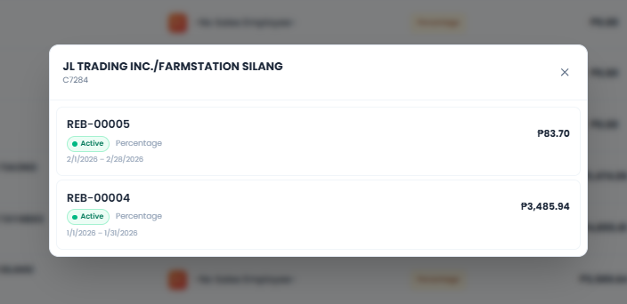
From the Status Summary, users can search for and select a specific customer. Upon clicking a customer record, the system displays the list of rebate programs associated with that customer. This provides a detailed view of the customer's participation across different rebate programs without cluttering the main summary screen.

The customer details view also includes a summary of the customer's rebate earnings, released amounts, and remaining balances for each rebate program. This structure allows users to quickly identify customer rebate performance while maintaining a clean and organized summary view.

Customer Details
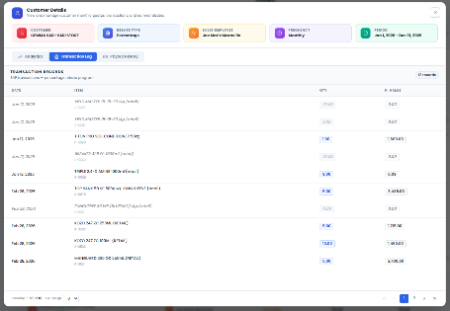
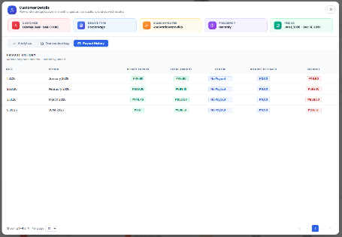
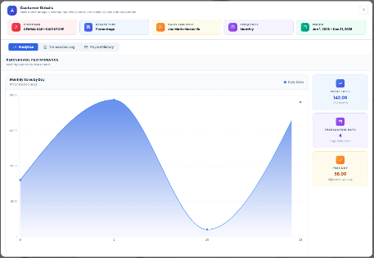

When a user selects a customer from the Status Summary and clicks a specific rebate program from the customer's program list, a detailed customer information window (modal) is displayed. This view provides a comprehensive breakdown of the customer's rebate performance and activity within the selected rebate program.

Analytics
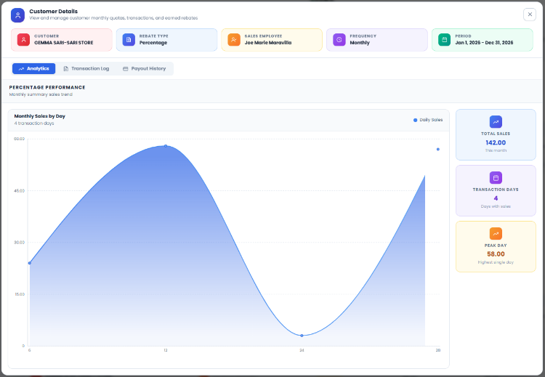
The Analytics section provides a graphical and summarized view of the customer's sales performance within the selected rebate program. The data is presented based on the program frequency, whether Monthly or Quarterly, and is derived from the eligible transactions retrieved from SAP.
This section displays the customer's sales activity by day within the selected month or quarter, allowing users to analyze sales trends and performance over time. In addition, it provides key performance indicators that help users quickly evaluate customer activity.
The Analytics section includes:
- Daily sales transactions within the selected period.
- Total sales quantity and sales amount.
- Number of transaction days.
- Peak sales day (highest sales day within the period).
- Monthly or quarterly sales performance summary.
- Sales trends based on eligible rebate transactions.
Key Functions:
- Visualizes customer sales performance.
- Displays daily sales activity.
- Shows total sales, transaction days, and peak sales day.
- Supports monthly and quarterly analysis.
- Provides insights into customer rebate qualification performance.

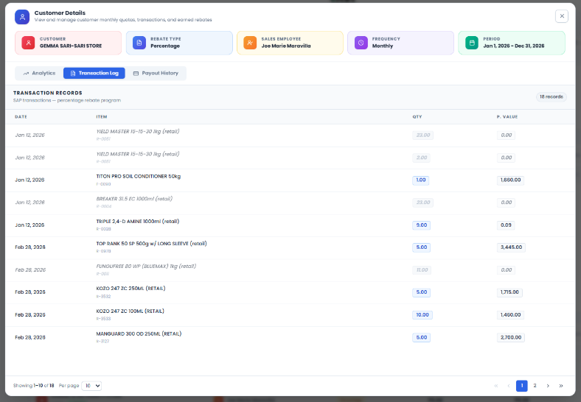
Transaction Log
The Transaction Log section contains the detailed transaction records used in the rebate computation process. The transactions displayed are filtered based on the rebate setup configuration, including the selected customer, eligible items, program period, and rebate criteria.
Only transactions that qualify under the rebate program are included. The system retrieves these records from SAP and automatically considers any applicable A/R Credit Memos (ARCM) when calculating the final eligible quantities and amounts. As a result, the displayed values already reflect the net quantities and sales amounts after adjustments.
This section serves as the transaction-level audit trail for rebate computation.
The Transaction Log includes:
- Transaction Date
- Item Code and Item Description
- Quantity Sold
- Total Sales Amount
- SAP-based transaction records
- Net quantities and amounts after ARCM adjustments
Key Functions:
- Displays eligible SAP transactions used in rebate computation.
- Filters records based on customer and configured rebate items.
- Automatically considers A/R Credit Memo (ARCM) adjustments.
- Provides transaction-level details for audit and verification.
- Shows computed quantities and sales amounts for rebate calculations.

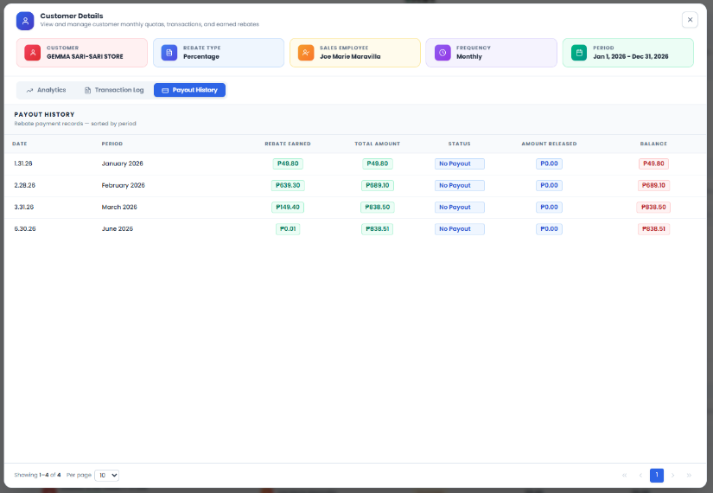
Payout History
The Payout History section is one of the core functions of the Rebate Management System, as it tracks the rebate earnings, payouts, and outstanding balances of customers across rebate programs.
This section displays the rebate results for each period, including the rebate earned, payout status, released amounts, and remaining balances. It provides complete visibility into the customer's rebate lifecycle, from earning rebates through final payment.
The Payout History includes:
- Rebate Date
- Rebate Period
- Rebate Earned Amount
- Amount Released
- Remaining Balance
- Payout Status
- Notes and References
The available payout statuses include:
- Paid – The rebate has been fully released and settled.
- Pending – The rebate has been computed but has not yet been fully released.
- No Payout – No eligible transactions were found for the period; therefore, no rebate was generated.
If a rebate period still has an outstanding balance, the remaining amount is automatically carried forward to the next rebate period and displayed as the Beginning Balance for the customer. This ensures that unpaid rebates are continuously tracked until they are fully settled.
In cases where a customer participates in multiple rebate programs, the system tracks payouts at the customer level. If a payment released through SAP fully settles the customer's outstanding rebate balance, the system automatically updates the related rebate records and marks the applicable rebate programs as Paid. The system also records notes indicating the source rebate program from which the balance was carried forward.
Key Functions:
- Tracks customer rebate earnings and payout history.
- Displays rebate period, earned amount, released amount, and balance.
- Supports Paid, Pending, and No Payout statuses.
- Automatically carries outstanding balances to future periods.
- Displays Beginning Balance for carried-over rebates.
- Integrates released payment information from SAP.
- Automatically updates rebate statuses when balances are fully settled.
- Records carry-over references and rebate program notes for audit purposes.

